Name :Khush Pithva 24BCE174
Subject : Data Structure (2CS501)
Practical no.: 6A
AIM : Write a program to implement phone book dictionary using Binary Search Tree which
provides following operations: (a) Add new entry in phone book, (b) Remove entry from
phone book, (c) Search phone number (d) List all entries in ascending order of name and
(e) List all entries in descending order of name.
INPUT :

#include <bits/stdc++.h>
using namespace std;

struct Node {
string name, number;
Node *left, *right;
Node(string n, string num)
{
name=n;
number=num;
left=right=NULL;
}
};

Node* insert(Node* root, string name, string number)
{
if(root == NULL) return new Node(name,number);
if(name < root->name) root->left = insert(root->left,name,number);
else if(name > root->name) root->right = insert(root->right,name,number);
else cout<<"Entry for "<<name<<" already exists.\n";
return root;
}

Node* search(Node* root, string name) {
if(root == NULL || root->name==name) return root;
if(name < root->name) return search(root->left,name);
return search(root->right,name);
}

void printasc(Node* root) {
if(root == NULL ) return;
printasc(root->left);
cout<<root->name<<" : "<<root->number<<"\n";
printasc(root->right);
}

void printdes(Node* root) {
if(root == NULL) return;
printdes(root->right);
cout<<root->name<<" : "<<root->number<<"\n";
printdes(root->left);
}

Node* findMin(Node* root) {
while(root->left != NULL) root = root->left;
return root;
}
Node* remove(Node* root,string name) {
if(root == NULL) {
cout<<"Entry for "<<name<<" does not exist.\n";
return root;
}
if(name < root->name) root->left = remove(root->left,name);
else if(name > root->name) root->right = remove(root->right,name);
else {
if(root->left == NULL){
Node* temp = root->right;
delete root;
return temp;
}
else if(root->right == NULL){
Node* temp = root->left;
delete root;
return temp;
}
Node* temp = findMin(root->right);
root->name = temp->name;
root->number = temp->number;
root->right = remove(root->right,temp->name);
}
}

int main() {
Node* root=NULL;
int ch; bool f=true;
while(f) {
cout<<"\n1.Add \n2.Remove \n3.Search \n4.Asc \n5.Desc \n6.Exit\nEnter your choice: ";
cin>>ch;
string n,num;
switch(ch) {
case 1:
cout<<"Name: ";
cin>>n;
cout<<"Number: ";
cin>>num;
root=insert(root,n,num);
break;
case 2:
cout<<"Name: ";
cin>>n;
root=remove(root,n);
break;
case 3:
cout<<"Name: ";
cin>>n;
{
Node* t=search(root,n);
if(!t) cout<<"Not found\n";
else cout<<t->name<<" : "<<t->number<<"\n";
}
break;
case 4:
printasc(root);
break;
case 5:
printdes(root);
break;
case 6: f=false; break;
}
}
return 0;
}
Output :

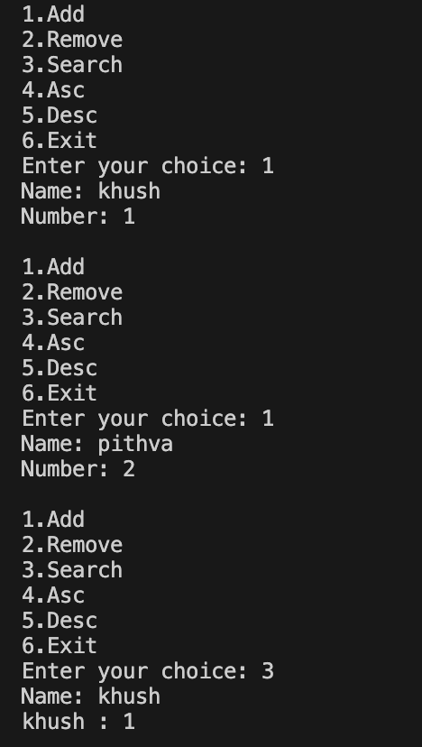
Practical No: 6(b)
Aim: Write a program to implement heap sort algorithm for sorting a given set of integers in ascending order.
Input:
#include <bits/stdc++.h>
using namespace std;

void mheap(int arr[], int n, int i)
{
int largest = i;
int left = 2 * i + 1;
int right = 2 * i + 2;

if (left < n && arr[left] > arr[largest])
largest = left;

if (right < n && arr[right] > arr[largest])
largest = right;

if (largest != i) {
swap(arr[i], arr[largest]);
mheap(arr, n, largest);
}
}
void builmheap(int arr[], int n)
{
for (int i = n / 2 - 1; i >= 0; i--)
mheap(arr, n, i);
}
void heapsort(int arr[], int n)
{
builmheap(arr, n);

for (int i = n - 1; i >= 0; i--) {
swap(arr[0], arr[i]);
mheap(arr, i, 0);
}
}

int main()
{
int arr[]={5,4,1,10,100,20,8};
int n=sizeof(arr)/sizeof(arr[0]);
heapsort(arr, n);
for(int i=0;i<n;i++){
cout<<arr[i]<<endl;
}
return 0;
}
OUTPUT:

